**TITLE OF PROJECT**

**IoT-Based Smart Streetlight System**

**ABSTRACT**

The energy demand of consumer is growing daily to consume energy, to use energy in effective and efficient way we developed a smart streetlight system.In General, Rural area's streetlight is manually operated but in Urban area street has solar powered streetlight which work on same system, but light brightness feature is not present yet also all light is connect through hub or centre. By reducing both Manpower and electricity waste energy conservation can be reduced by this system. Saving energy has always been the primary objective because thermal and hydropower sources are declining for a variety of reasons.

Streetlights are an basic element of any street it provide clear night vision to secure roads and public areas but it been consuming a substantial amount of electricity in the existing streetlight system lights which Are operating from sunset to sunrise streetlight work with full brightness even there is visibility the light brightness also can be controlled to prevent energy this can be achieved using an IoT-based smart streetlight system.

The smart streetlight system works with light dependent resistor with detect light, when light with defined intensity level drops on LDR sensor then system with turn on LED lights along with Infrared Object Detection Sensors (IR) enable Brightness controlled variation of led when IR sensor detectsmovement of the object which is infeasible with HID lamps. We replace old HID lamps with Energy-efficient LEDs. These LED uses low power electricity than HID lamps. Coupled with Solar powered Battery this system works on natural energy. which help in Power consumption and cost-effectiveness.

**INTRODUCTION**

IoT-based Smart Streetlight System is an auto smart streetlight to save energy. The streetlights switch on at dusk when the value of ldr decreases below the defined threshold value. The streetlights turn on with half brightness, and then in the morning when the LDR value increases above the threshold value, the microcontroller turns off the streetlights. When there are objects surrounding the post, when it is dark, the object detection sensor (IR) detects the object and increases the brightness of the LED light to full, and when IR doesn’t detect the value, the brightness goes back to half. When the solar panel receives solar rays, the charging module charges battery when solar panels receives sunrays. Old HID has been lamps replace by White light-emitting diodes (LED) in street lighting systems to include a dimming feature. The high-intensity discharge (HID) lamp, which usually appears in urban streetlights, cannot be used to control the Brightness of Light. Because of their high lifespan and low energy consumption, LED lights are the lighting of the future. As a result, it is a solution to the drawbacks of old streetlights. Energy costs can be cut by over 35% with the help of smart on/off systems, targeted progressive brightness control features, and systematic use of energy.

We may decrease our average cost of consumption by up to 42% by implementing routine conservation efforts. While it is valuable to establish an IoT-based smart streetlight system across all signal posts, the requirements must be clearly stated as they are usually misunderstood.

**EXISTING SYSTEM**

**Traditional streetlights**

They use power from electrical grid, which generates energy from hydro powered and fossil fuel (non-renewable) sources. This existing system, lights must be switched ON/OFF manually, brightness of the light cannot be controlled, and electricity consumption is high. Since the lights are at maximum brightness, the whole night more electricity is consumed. It has fully manual control of streetlight and has only ON/OFF feature.

**Solar powered streetlight**

Solar powered streetlights starts after Sunset and it automatically turns on the lights. This sensor that receives the sunlight which turn off lights when in the morning sunlight falls on it.

This existing system, the light switches ON/OFF automatically, but brightness of the light has not been controlled, and electricity consumption cannot be reduced because it uses full power all night so energy which is conserve from solar can’t save.

**PROPOSED SYSTEM**

This purposed system offers the automatic smart streetlight system which is powered by solar energy which is connected to charging module which charge the battery, if by chance any power failure occurs in solar panels then system charge battery with electric grid until solar charging system repaired.

***In figure 1***, Streetlight starts with micro-controller “ESP-WROOM-32” which is connected from battery which is connected to a central hub of an area where all connection connected. Micro-controller take input from LDR sensor which detect sunlight intensity value, when this value decrease from threshold value then system turn on the light with 50% brightness and when input from IR Sensor detect any object than brightness increases from 50% to 100%, If any object not detected by IR Sensor, then after few second LED brightness revert to 50% and when LDR sensor detect sunlight intensity value, which increases from threshold value then system turn of the light and micro controller goes to sleep and charging module connect from solar panel start charging the batteries.

***Figure 1. system’s Block diagram***

***In figure 2,*** We have central hub of an area which contains batteries which are connected with charging module which connected which solar panels and main electric grid, which is used as backup, microcontroller and LDR. When LDR sensor receives value less then threshold then all LED light in street are turn on with 50 % brightness which is show by light yellow in *figure 2*, as IR sensor detect any object light brightness increases to 100% which is bright yellow as shown in *figure 2,*That pole which IR sensor receives high value only, to maintain visibility and stability we set 2 pole in increment set to increase brightness.

When object did not detect it remain 50% brightness, When LDR sensor signals that intensity value increases from threshold value then system turn off the light and micro controller goes to sleep upto ldr sensor signal low value then threshold again system turn on from sleep.

***Figure 2. diagram of streetlight system***

**WORKING SYSTEM**

***In figure 3***, We have LDR sensor, IR sensor, Led Light, solar panel ,battery, charging module, wires and a micro-controller(esp-wroom-32).

* Solar panel and battery are connected with charging module with Positive(+) and Negative(+) terminals with Red(+) and Black(-) wires.
* Charging module is connected with microcontroller with positive with 3v3 and negative with GND.
* LDR sensor connected with microcontroller with VCC to 3v3, GND to GND and A0(analog input) to Pin 34.
* IR sensor connected with microcontroller with VCC to 3v3, GND to GND and OUT(digital input) to Pin 26.
* Led bulb is connected with its Positive and negative terminal to Pin 19 and GND.

***Figure 3. Circuit of working system***

**Algorithm of Working System**

Step 1: Start

Step 2: Declare variables, threshold, and initialize the pins of LEDs and all sensors into variables.

Step 3: set pinMode of leds as OUTPUT and sensors as INPUT in void setup ().

Step 4: Enter in void loop().

Step 5: Read the values from Sensors.

Step 6: Store values in variable as a digital value.

Step 7: Check if ldrValue is less than the threshold (threshold value is sunlight intensity).

1. If yes then, Check irValue is equal to HIGH.
2. If yes then, Turn on Lights with 100 % brightness, and goto Step 4.
3. Else Turn on Lights with 50% brightness, and goto Step 4
4. Else Turn off the Lights, and goto Step 4.

Step 8: Stop.

**Flow chart of working system**

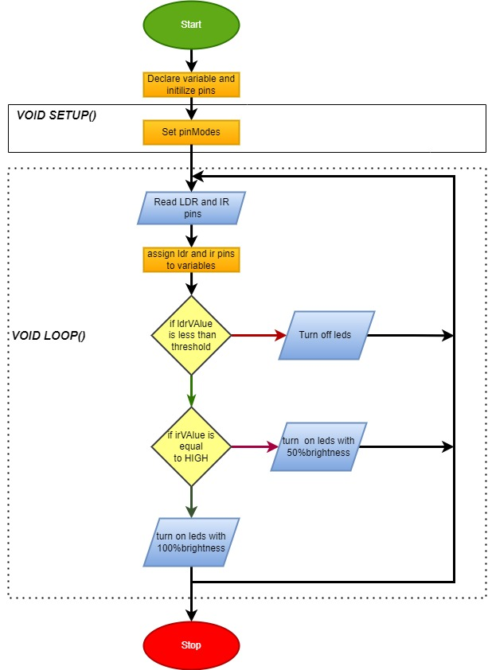

***Fig 4. Flow chart of working system***

**HARDWARE REQUIREMENTS**

**ESP-WROOM-32 Module**

***In Figure 5,*** The ESP-WROOM-32 is micro-controller has connectivity of 2.4Gh Wi-Fi and Bluetooth. This module have many functionalities like it includes low-powered sensor networks, MP3 decoding, music streaming, and voice encoding. The ESP32 has a chipset named “Tensilica Xtensa” which is a Dual-Core 32-bit LX6 microprocessor. The integrated chip has flexible design elements with two independent CPU cores which provides clock frequency range of 80 MHz to 240 MHz and for basic calculations like peripheral monitoring, the chip contains low-power co-processor that may be used in place of the CPU to conserve power. The overall system uses a little amount of PCB space.

Because the chip's has operating voltage of 2.2v to 3.6v, this board consists of an step-down voltage regulator to run chip stable at 3.3V(600 mA), which is sufficient even when the ESP-Wroom-32 is drawing its High current. The chip’s 3.3V regulator is connected with pin 3V3. This pin gives power externally. This board can be powered by the Micro-B USB connector that connect in-board.

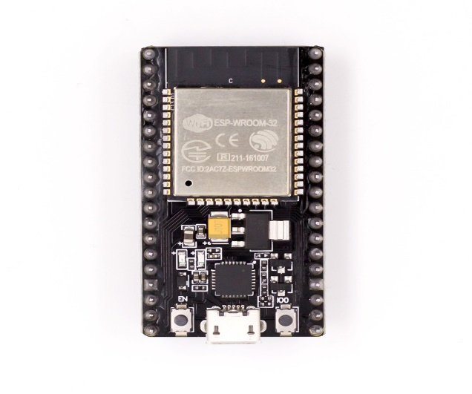

***Figure 5. ESP-WROOM-32***

**Application :**

* Used to make a Central hub with low-powered functions.
* Used to control Home automation devices.
* Used to create a Mesh network.
* Used in to control Industry wireless.
* Used to control any Sensor networks.

**Light Dependent Resistor**

***In Figure 6,*** An LDR or photo resistor's resistance work with the electromagnetic radiation that it receives. They are also called photoconductors and photocells. High-resistance semiconductor materials are used in their construction. One of the most used symbols for an LDR is shown ***in Figure 7*** below.

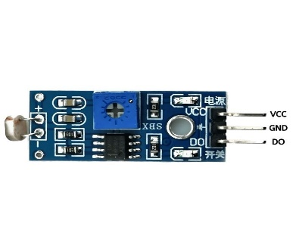 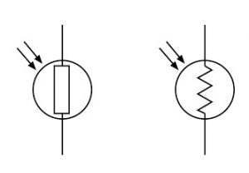

***Figure 6. LDR SENSOR Figure 7. LDR Symbols***

The LDR works on the principle of resistance and light intensity; when the light intensity starts increasing, the resistance starts decreasing.

***In Figure 8,*** In the dark, the light will decrease and resistance increases in LDR, due to increased resistance the current will flow less. But the current will flow high in the dark which helps to glow the streetlight in the dark.

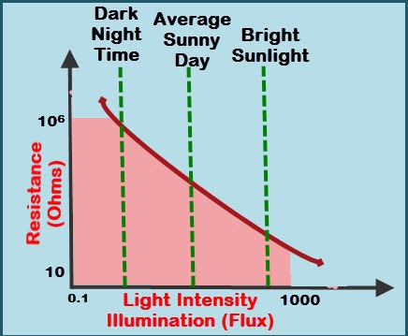

***Figure 8. LDR Working***

**Infrared Obstacle Avoidance IR Sensor Module**

An IR sensor throws light that detects any object which strikes it. An IR sensor can detect an object's heat and spot the movement of the object. basically, all items throw a kind of heat radiation in the infrared range these kinds of radiation are undetectable to the human eye, but infrared sensors can pick them up.

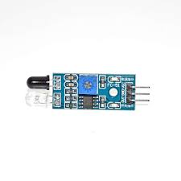

***Figure 9. ir sensor***

**Working Principle of ir**

An IR sensor consists of two leds anode(IR transmitter) and a diode (IR Receiver).They are called as PhotoCoupler.

**IR transmitter**

***In figure 10,*** An infrared transmitter is LED that throws infrared radiation. Although an IR transmitter look like a regular LED. Its throw radiation which we cannot see from human eyes.

**IR Receiver**

***In figure 11,*** IR transmitter is a diodes. It only pick up on infrared radiation.

.

[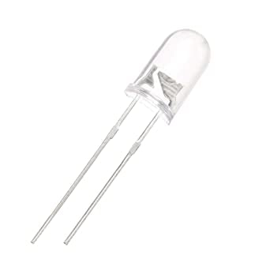](https://robu.in/wp-content/uploads/2020/05/51fibl-5xL._SX342_.jpg) [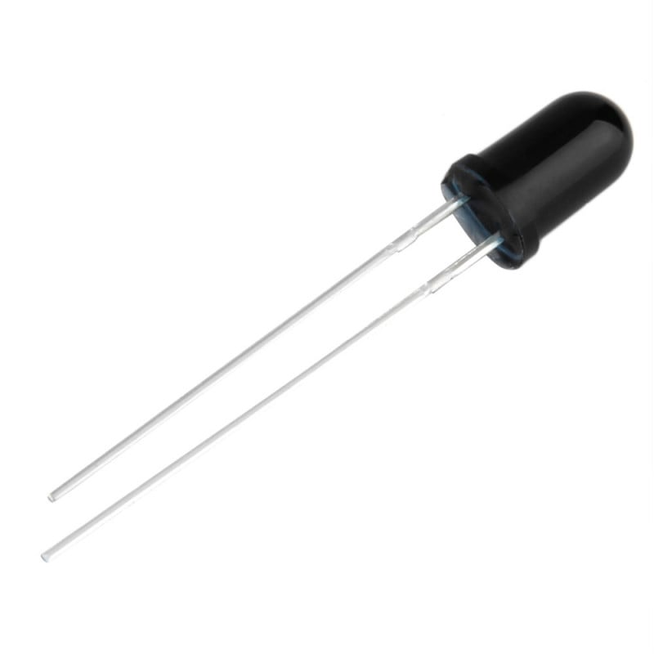](https://robu.in/wp-content/uploads/2020/05/SN-IR-R-0-1-1-800x800-1.jpg)

***Figure 10. ir transmitter Figure 11. ir receiver***

***In Figure 12, the*** IR sensor works by combining the IR transmitter and receiver which work when the IR transmitter throes infrared rays which strike the object and reflect back then the IR receiver catches these rays.

[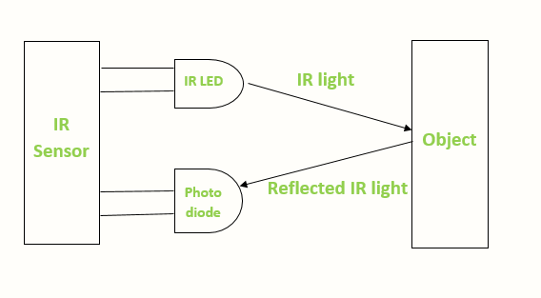](https://robu.in/wp-content/uploads/2020/05/IR-sensor-Working.png)

***Fig 12 IR sensor working***

**TECHNICAL ADVANTAGES AND BENEFITS**

1. **Energy Efficiency:** Using the LDR module, the system makes sure that the lights run at 50% brightness during the night. According to the ambient light levels, the system continually modifies the street lights' brightness. And the system consumes less energy than if lights were left running all the time. This optimization lowers energy use and boosts overall energy effectiveness.
2. **2. Object Detection:** The system can detect objects on the street because of to the addition of the IR module. The lights automatically glow at 100% of the next 2 poles' brightness when an object is detected. By improving visibility for people in road, this feature improves safety. It enhances general road safety and assists in preventing accidents.
3. **Automated Control:** Real-time monitoring and management of the street light system are possible because to the IoT features of the ESP32 WROOM board. Without human involvement, the system responds to variations in ambient light and object detection. By automating the process, streetlights no longer need to be manually adjusted, and the best possible lighting is always present.
4. **Optimal Battery Charging:** The technology uses a lithium battery and solar panel combo. The lights are switched down and the solar panel begins to recharge the battery during the day when the LDR module detects sunshine. The battery is kept charged and prepared for overnight operation thanks to its effective charging method. It encourages the adoption of renewable energy sources while reducing reliance on the grid.
5. **Cost-Effectiveness:** The IoT-enabled smart street light system provides long-term cost savings by maximizing energy use. The utilization of solar energy lessens dependence on conventional energy sources, while smart energy management lowers electricity costs. The system's automatic control also does away with the need for manual maintenance and monitoring, bringing down operating expenses even more.
6. **Low-Power Mode:** The system may further optimize energy use and increase battery life by making use of low-power modes and sleep states. In this smart streetlight system's ESP32 WROOM board has been programmed to function in low-power mode. This feature enables the microcontroller to use the minimal amount of power needed if there is hardly any activity.